Basic Task2; Use Password Manager

# Steps;

1. Install Bitwarden.
2. Logged in with Master Password.
3. Generate the strong Password.

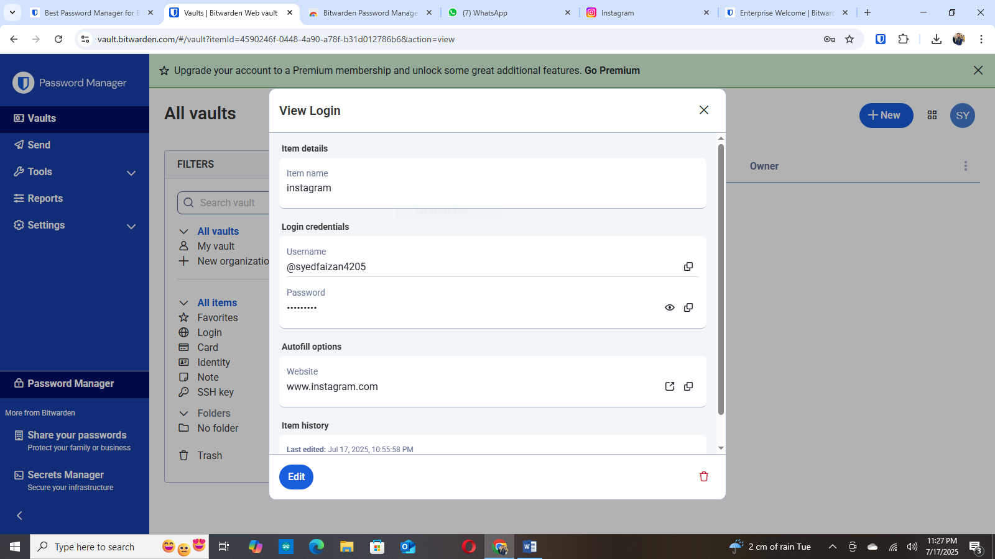

1. Enabled and use autofill.

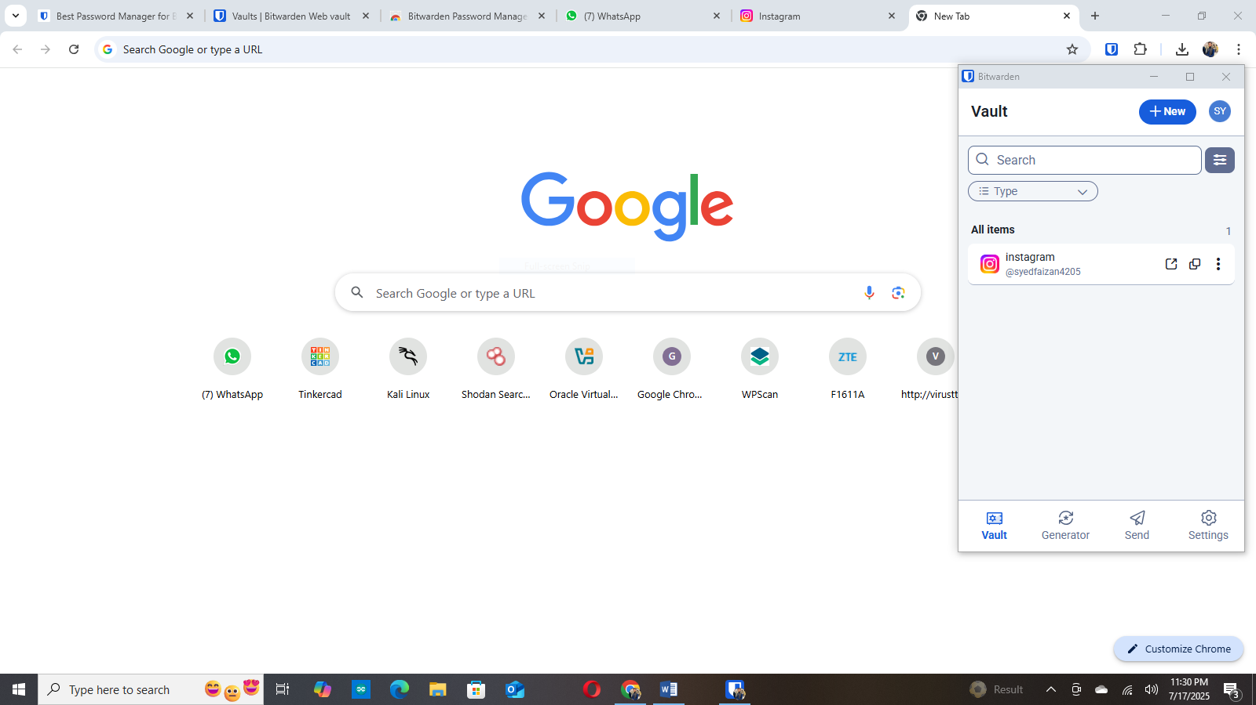

1. Confirmed Bitwarden is replacing Google autofill.